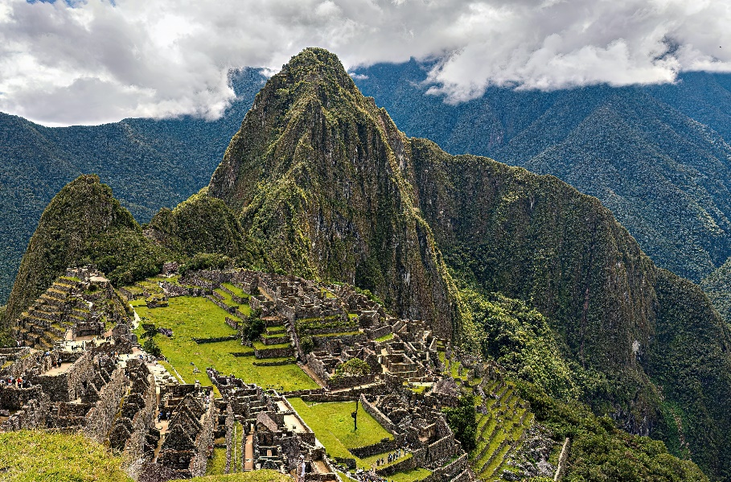

History of Machu Picchu

Machu Picchu is an ancient Inca citadel located in the Andes Mountains of Peru. It is renowned for its stunning architecture, historical significance, and breathtaking natural surroundings. Here is an overview of the history of Machu Picchu:

**1. \*Inca Construction (15th Century):\*** Machu Picchu was built during the height of the Inca Empire in the 15th century. Its construction is attributed to the Inca ruler Pachacuti Inca Yupanqui, who ordered its construction around 1450 CE. The exact purpose of the site is still debated, but it is believed to have served as a royal estate or retreat.

**2. \*Architectural Marvel:\*** Machu Picchu is renowned for its sophisticated dry-stone construction, characterized by precisely cut and fitted stones without the use of mortar. The site includes temples, plazas, terraces, and residential buildings, all integrated harmoniously with the natural landscape.

**3. \*Abandonment and Rediscovery:\*** Machu Picchu was inhabited for only a relatively short period, possibly a few decades. It was abandoned around the time of the Spanish conquest in the 16th century. The site was largely forgotten by the outside world until it was rediscovered by American historian and explorer Hiram Bingham in 1911.

**4. \*Spanish Conquest:\*** Machu Picchu likely escaped the widespread destruction and looting by the Spanish conquistadors due to its remote location and the fact that it was not well-documented in historical records.

**5. \*Cultural Significance**:\* Machu Picchu is believed to have had significant religious and ceremonial importance for the Inca civilization. Its precise purpose remains a subject of debate, but it is thought to have served as a retreat or sanctuary for the Inca elite.

**6. \*UNESCO World Heritage Site**:\* In 1983, Machu Picchu was designated as a UNESCO World Heritage Site to protect and preserve its historical and cultural significance. It is also considered one of the New Seven Wonders of the World.

**7. \*Tourism:\*** Machu Picchu has become one of the most popular tourist destinations in the world, attracting visitors from all over the globe. Its popularity has raised concerns about environmental impact and conservation, leading to measures to limit the number of visitors.

**8. \*Ongoing Research and Conservation:\*** Archaeological studies, preservation efforts, and ongoing research continue to uncover new insights into Machu Picchu's history and significance. Preservation work is also being carried out to protect the site from erosion and environmental damage.

Machu Picchu stands as a remarkable testament to the architectural and engineering achievements of the Inca civilization and serves as a symbol of Peru's rich cultural heritage. It remains one of the most iconic and awe-inspiring archaeological sites in the world.